SIMATS ENGINEERING
ASSESSMENT TOOL 1
Application-Based Questions

COURSE NAME: INTERNET PROGRAMMING
COURSE CODE: CSA4304
Name: A. Pranay Durgesh Varma

REGNO:192425094

COURSE OUTCOME COVERED

CO-1 : Develop well-structured, standards-compliant web pages using HTML/XHTML and XML, and apply Internet protocols and HTTP communication mechanisms for web content
delivery. (L2)

Assessment Tool : Application-Based Questions

Weightage: 40%

QUESTIONS: Total Marks: 30

1: Online Symposium Portal
A college is developing an online symposium registration portal. The following HTML structure and HTTP interaction is observed:
<form action="/register" method="POST">
<input type="text" name="name">
<input type="email" name="email">
<button>Submit</button>
</form>
When a student submits the form, the browser sends an HTTP request to the server, and the server responds accordingly.
Questions:
- Identify appropriate HTML5 semantic elements missing in the structure.

- <header> – Displays the page title or logo.
- <main> – Contains the main content of the webpage.
- <section> – Groups related content, such as the registration form.
- <footer> – Displays copyright or contact information.
- <label> – Provides descriptive text for form input fields.

- Modify the structure to make it standards-compliant.

<!DOCTYPE html>
<html lang="en">
<head>
<meta charset="UTF-8">
<meta name="viewport" content="width=device-width, initial-scale=1.0">
<title>Online Symposium Portal</title>
</head>
<body>

<header>
<h1>Online Symposium Portal</h1>
</header>

<main>
<section>
<h2>Student Registration</h2>

<form onsubmit="showMessage(event)">

<label for="name">Name:</label>
<input type="text" id="name" name="name" required>

<br><br>

<label for="email">Email:</label>
<input type="email" id="email" name="email" required>

<br><br>

<button type="submit">Submit</button>

</form>

<p id="message"></p>
</section>
</main>

<footer>
<p>&copy; 2026 College Symposium</p>
</footer>

<script> function showMessage(event) {
event.preventDefault();

let name = document.getElementById("name").value; let email = document.getElementById("email").value;

document.getElementById("message").innerHTML =
"Registration Successful!<br>" +
"Name: " + name + "<br>" +
"Email: " + email;
}
</script>

</body>
</html>

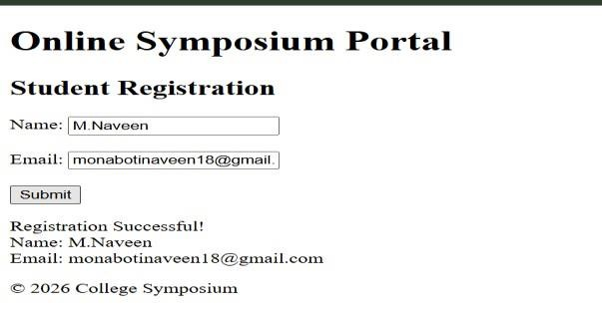

- Interpret the HTTP request generated during form submission.

POST /register HTTP/1.1
Host: www.college.edu
Content-Type: application/x-www-form-urlencoded Content-Length:
42
name=M.Naveen&email=monabotinaveen18@gmail.com

- Analyze the HTTP response cycle from server to browser.

When a student submits the registration form, the browser sends an HTTP POST request containing the student's name and email to the server. The server receives the request, validates the submitted data, and processes it. If the information is valid, the server stores the registration details in the database. After processing, the server generates an HTTP response with a status code such as 200 OK (successful request) or 201 Created (resource created).
HTTP Response Cycle:
- User submits the registration form.
- Browser sends an HTTP POST request to the server.
- Server validates and processes the data.
- Server stores the data in the database (if valid).
- Server sends an HTTP response to the browser.
- Browser displays the success or error page.

5. Suggest improvements for usability and accessibility.
The symposium registration form can be improved by making it more user-friendly and accessible. Each input field should have a <label> so users and screen readers can easily identify its purpose. The required attribute should be used to ensure mandatory fields are filled before submission. Adding placeholder text provides users with examples of the expected input. Proper HTML5 semantic elements such as <header>, <main>, <section>, and <footer> improve the page structure and accessibility.

2: Cross-Browser Compatibility Issue
A company website shows inconsistent layout across browsers. The following HTML snippet is
used:
<html>
<head>
<title>Company</title>
</head>
<body>
<div>
<h1>Welcome
<p>About us
</div>
</body>
</html>
Questions:
1. Identify improper nesting and missing closing tags.
<html>
<head>
<title>Company</title>
</head>
<body>
<div>
<h1>Welcome</h1>
<p>About us</p>
</div>
</body>
</html>

- Analyze how different browsers may interpret this structure.
Different web browsers use different rendering engines to display web pages. When HTML contains missing closing tags or improper nesting, browsers automatically try to fix the errors. However, each browser may correct the HTML differently. As a result, the layout, spacing, fonts, and alignment of the webpage may vary between browsers such as Chrome, Firefox, Edge, and Safari.

- Identify missing semantic elements (e.g., header, section).

The HTML structure is missing important HTML5 semantic elements that improve the organization, accessibility, and readability of the webpage.
Missing Semantic Elements
- <header> – Contains the page title or logo.
- <main> – Contains the main content.
- <section> – Groups related content.
- <footer> – Contains copyright or contact information.

4. Provide a corrected W3C-compliant HTML structure.

<!DOCTYPE html>
<html lang="en">
<head>
<meta charset="UTF-8">
<meta name="viewport" content="width=device-width, initial-scale=1.0">
<title>Company</title>
</head>

<body>
<header>
<h1>Company</h1>
</header>

<main>
<section>
<h2>Welcome</h2>
<p>About us</p>
</section>
</main>

<footer>
<p>&copy; 2026 Company</p>
</footer>

</body>
</html>
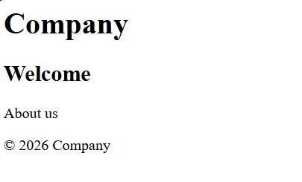

5. Suggest techniques to ensure cross-browser compatibility.
To ensure that a website works consistently across different browsers, developers should follow standard web development practices. HTML should be validated using W3C standards to avoid syntax errors. Semantic HTML5 elements should be used for better structure and accessibility. CSS should include browser-compatible properties, and developers can use CSS resets or Normalize.css to maintain consistent styling. Responsive design techniques such as the viewport meta tag should be

3: Form Submission Failure
A web application fails to send form data to the server. The following configuration is observed:
<form action="/submit" method="GET">
<input type="text" name="username">
<input type="password" name="password">
<button type="button">Login</button>
</form>
Questions:
- Identify issues in the form configuration.
<form action="/submit" method="POST">
<input type="text" name="username">
<input type="password" name="password">
<button type="submit">Login</button>
</form>
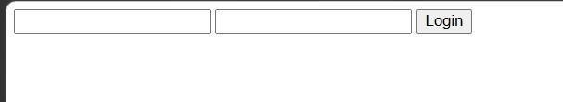
- Analyze why the HTTP request is not triggered.

The HTTP request is not triggered because the button is defined as type="button". A button with this type performs no action unless JavaScript is used. Since there is no JavaScript code to submit the form, clicking the button does nothing. Changing the button type to submit automatically sends the form data to the server.

- Interpret the role of GET method in this scenario.
The GET method sends form data by appending it to the URL as query parameters. It is mainly used to retrieve data from the server and should not be used for login forms because sensitive information such as usernames and passwords becomes visible in the browser's address bar, browser history, and server logs. In this scenario, using the POST method is more appropriate because it sends the data in the request body, making it more secure.

- Propose a corrected implementation.
<!DOCTYPE html>
<html lang="en">
<head>
<meta charset="UTF-8">
<meta name="viewport" content="width=device-width, initialscale=1.0">
<title>Login Form</title>
</head>
<body>

<main>
<h1>Login Form</h1>

<
<label for="password">Password:</label>
<input type="password" id="password" name="password" required>

<br><br>

<button type="submit">Login</button>

</form>

<p id="result"></p>
</main>

<script> function loginUser(event) {
event.preventDefault();

let username =
document.getElementById("username").value;

document.getElementById("result").innerHTML =
"Login Successful!<br>Welcome, " + username;
}
</script>

</body>
</html>
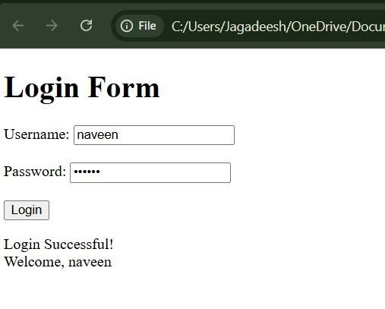

5. Suggest improvements for secure data transmission.
To improve the security of the login form, the POST method should be used instead of GET so that sensitive information is not included in the URL. The website should use HTTPS to encrypt data while it is transmitted between the browser and the server. Input fields should include the required attribute to ensure that users enter all necessary information before submitting the form. The server should validate and sanitize all user inputs to prevent attacks such as SQL Injection and Cross-Site Scripting (XSS). Passwords should never be stored in plain text; instead, they should be securely hashed before storage.

Code of Conduct:

I A. Pranay Durgesh Varma/ 192425094 that this submission is my original work and that I have adhered to the guidelines specified for this assessment.
I understand that any violation of academic integrity rules will result in disciplinary action.

Signature of the student:
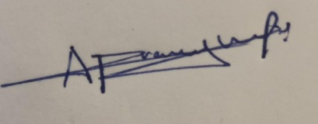

RUBRICS FOR CALCULATION:

Criteria | Weig htage | Level 4 –  Exemplary | Level 3 –  Proficient | Level 2 –  Developing | Level 1 –  Beginning
Understanding of Concepts | 25% | Demonstrates thorough, accurate  understanding of concepts | Good understanding with minor gaps | Basic understanding with some  misconception  s | Poor understandin g; major  misconceptio  ns
Explanation | 25% | Detailed, wellexplained  answers with  relevant examples | Clear explanation with adequate details | Limited explanation; lacks depth | Poor or unclear explanation
Application | 20% | Effectively applies concepts with strong analytical ability | Applies concepts with minor errors | Limited application with weak analysis | No application or  incorrect analysis
Organization | 15% | Well-structured answers with logical flow and coherence | Organized with minor issues in  flow | Basic structure, lacks  clarity | Poor organization, incoherent answers
Accuracy | 10% | Completely accurate and covers all  required points | Mostly accurate with minor omissions | Partially correct with missing points | Incorrect answers with major gaps
Clarity | 5% | Clear, neat, professional presentation | Understandable with minor issues | Limited clarity, readability issues | Poorly written, difficult to  understand

